**Experiment No:** 01

**Experiment Name:** How to install Linux /Ubuntu.

**Objectives:**To Learn how to install Linux/Ubuntu

**Methodology** : The procedure in order to set up Linux/Ubuntu is describe below.

**1.Create a bootable USB drive:**

screenshot:

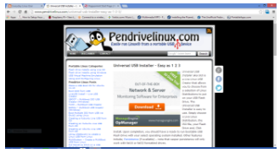

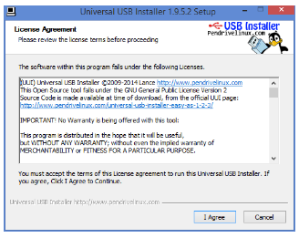

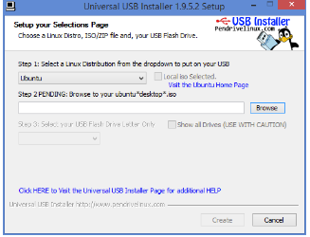

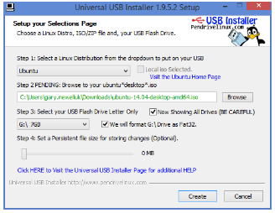

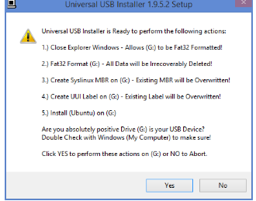

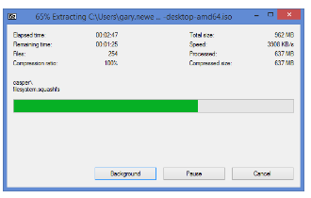

**2.Boot from Pen Drive:**

screenshot:

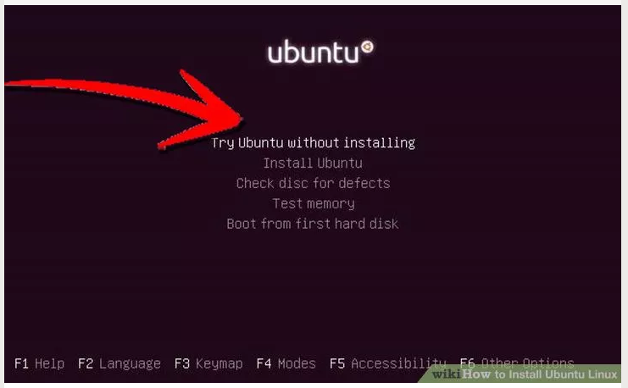

**3.Try Ubuntu before installing:**

screenshot:

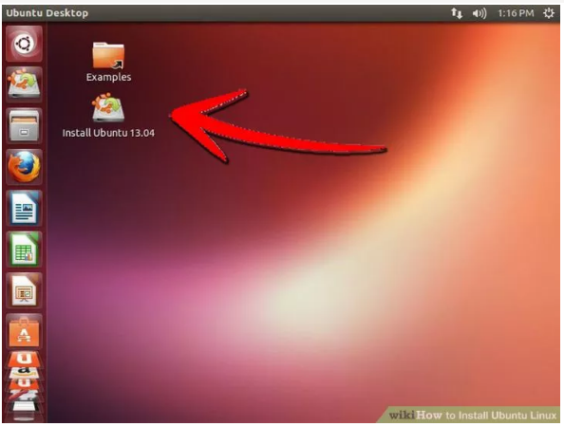

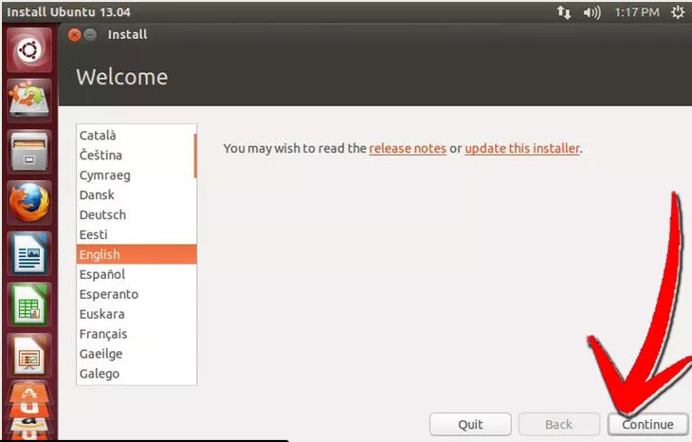

**4.Install Ubuntu:**

Screenshot:

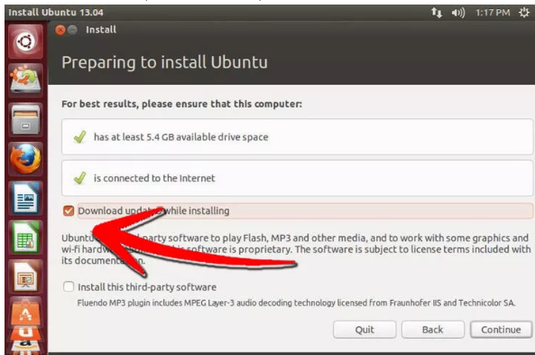

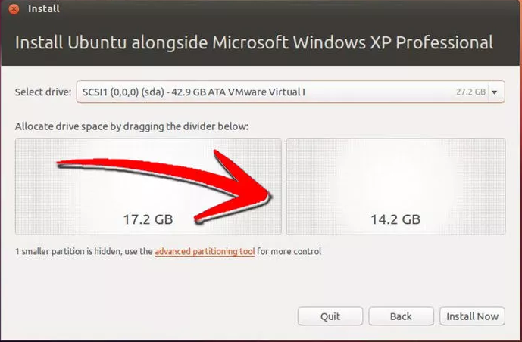

**5.Choose your location:**

screenshot:

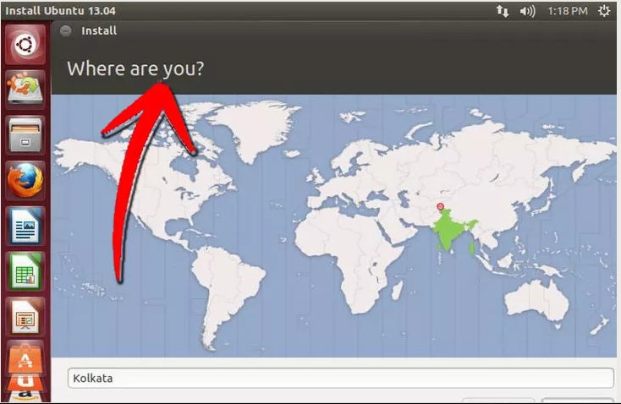

**6.Set your keyboard layout:**

Screenshot:

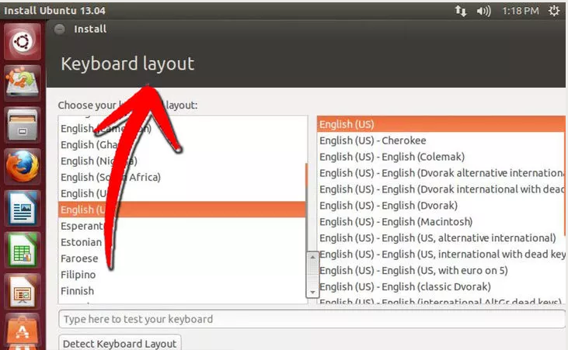

**7.Enter your login information:**

Screenshot:

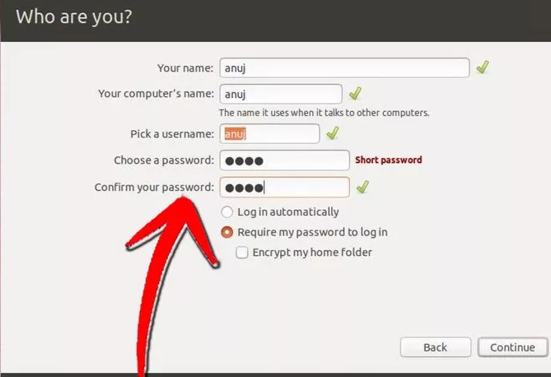

**8.Wait for the installation process to complete**:

Screenshot:

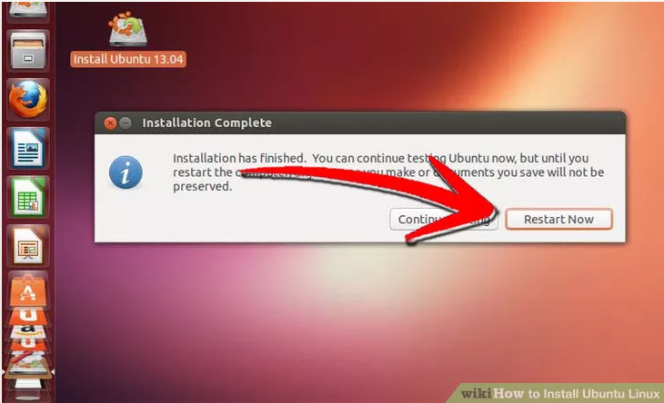

Discussion: In this Lab experiment, We learn about the important topic on installation Linux/Ubuntu. we successfully done it.